Observation 1:

Select'pg_mega_irisk_assessment_issues_final', Count(distinct MEGA_HEX_ID)

from png_mdsdb.pg_mega_irisk_assessment_issues_final where cdctype<>'D' group by 1

UNION

SELECT 'pg_mega_legacyg1_final',Count(distinct MEGA_ID)

from png_mdsdb.pg_mega_legacyg1_final where cdctype<>'D' group by 1

UNION

SELECT 'pg_mega_legacyg234_final',Count(distinct Mega_ID)

FROM png_mdsdb.pg_mega_legacyg234_final where cdctype<>'D' group by 1;

Query :2

SELECT Count(1) as CNT

FROM ldb.f_rita_application_c_fact a

JOIN ldb.d_rita_application_c b ON a.rita_application_c_key=b.row_key

JOIN ldb.d_lov_processing_activities_ot_repository_type_c c ON b.application_nature_c_key=c.row_key

JOIN ldb.d_processing_activities_managing_organization_c d ON a.managing_organization_c_key=d.row_key

JOIN ldb.d_lov_processing_activities_ot_life_cycle_status_c e ON b.data_asset_lifecycle_status_key=e.row_key

JOIN ldb.d_application_pg_data_privacy_c f ON b.application_pg_data_privacy_c_key=f.row_key

WHERE

(

b.grace_period_c='Already in VP Tracker'

AND b.gdpr_rel_cal_overwritten='Y'

AND e.source_dimension_name IN ('Design/Build', 'Exception', 'Launch/Deploy', 'Leverage/Optimize', 'Qualify/Deliver', 'Retired', 'Sunset')

AND f.dimension_name IN ('High', 'Low', 'Medium')

AND c.cust_dimension_name_c IN ('Application', 'Application - Externally Owned', 'Component', 'NonDigital')

AND d.lev_1_organization_name IN

(

'Consumer Services','FSS',

'IDQ','Information Security','IT Consumer Solutions',

'IT Customer Solutions & Delivery','IT Data & Analytics Organization',

'IT Solutions','MANAGEMENT SERVICES','Master Data Organization','MY PG SERVICES','IT IT innovation Organization',

'PS Shared Services & Technology Operations','PTW'

)

)

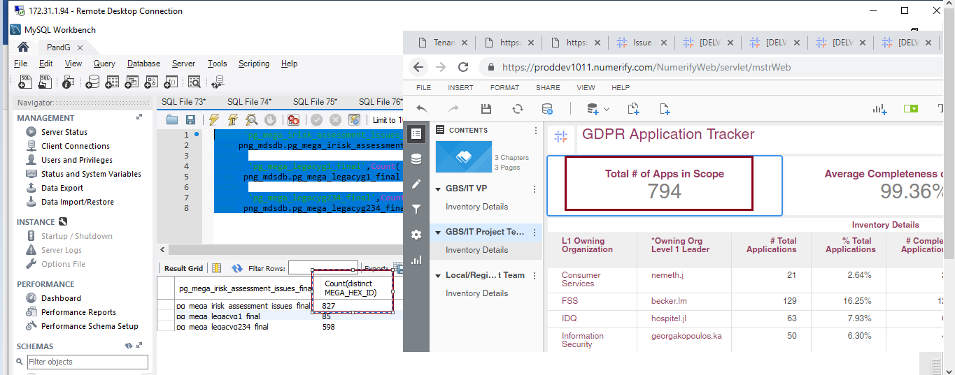

Observation 2:

There are 94 records where the Application is meeting the Project Team filter , but not available in all three files.

Query :

SELECT a.row_id,a.soft_deleted_flag

FROM ldb.f_rita_application_c_fact a

JOIN ldb.d_rita_application_c b ON a.rita_application_c_key=b.row_key

JOIN ldb.d_lov_processing_activities_ot_repository_type_c c ON b.application_nature_c_key=c.row_key

JOIN ldb.d_processing_activities_managing_organization_c d ON a.managing_organization_c_key=d.row_key

JOIN ldb.d_lov_processing_activities_ot_life_cycle_status_c e ON b.data_asset_lifecycle_status_key=e.row_key

JOIN ldb.d_application_pg_data_privacy_c f ON b.application_pg_data_privacy_c_key=f.row_key

JOIN ldb.d_lov_mega_integrity_rating_c x ON b.pg_bia_rating_for_integrity_c_key=x.row_key

JOIN ldb.d_lov_mega_confident_rating_c x1 ON b.pg_bia_confidentiality_rating_c_key=x1.row_key

JOIN ldb.d_lov_mega_availability_rating_c x2 ON b.pg_bia_availability_rating_c_key=x2.row_key

WHERE

(

b.grace_period_c='Already in VP Tracker'

AND b.gdpr_rel_cal_overwritten='Y'

AND e.source_dimension_name IN ('Design/Build', 'Exception', 'Launch/Deploy', 'Leverage/Optimize', 'Qualify/Deliver', 'Retired', 'Sunset')

AND f.dimension_name IN ('High', 'Low', 'Medium')

AND c.cust_dimension_name_c IN ('Application', 'Application - Externally Owned', 'Component', 'NonDigital')

AND d.lev_1_organization_name IN

(

'Consumer Services','FSS',

'IDQ','Information Security','IT Consumer Solutions',

'IT Customer Solutions & Delivery','IT Data & Analytics Organization',

'IT Solutions','MANAGEMENT SERVICES','Master Data Organization','MY PG SERVICES','IT IT innovation Organization',

'PS Shared Services & Technology Operations','PTW'

)

)

AND b.row_id='079207F75A943058'

